***\*\*JAVA\*\****

**1.Find Armstrong number**

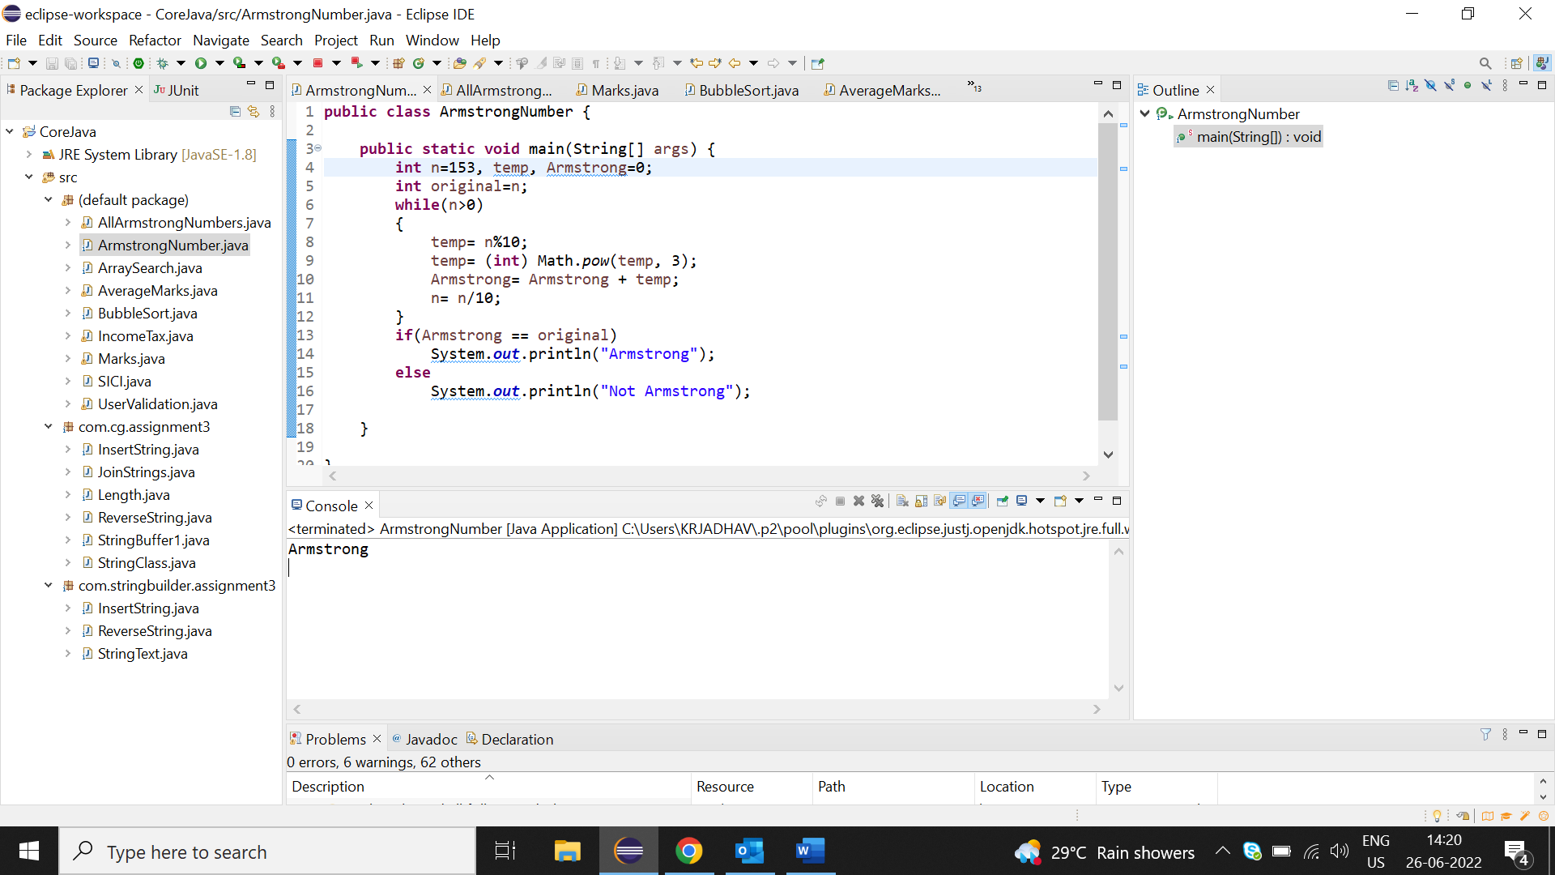

**2.Armstrong nos. in range 100-999**

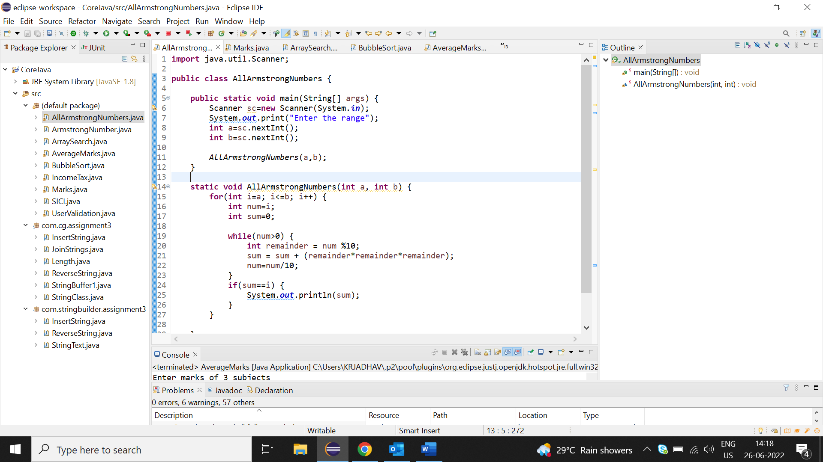

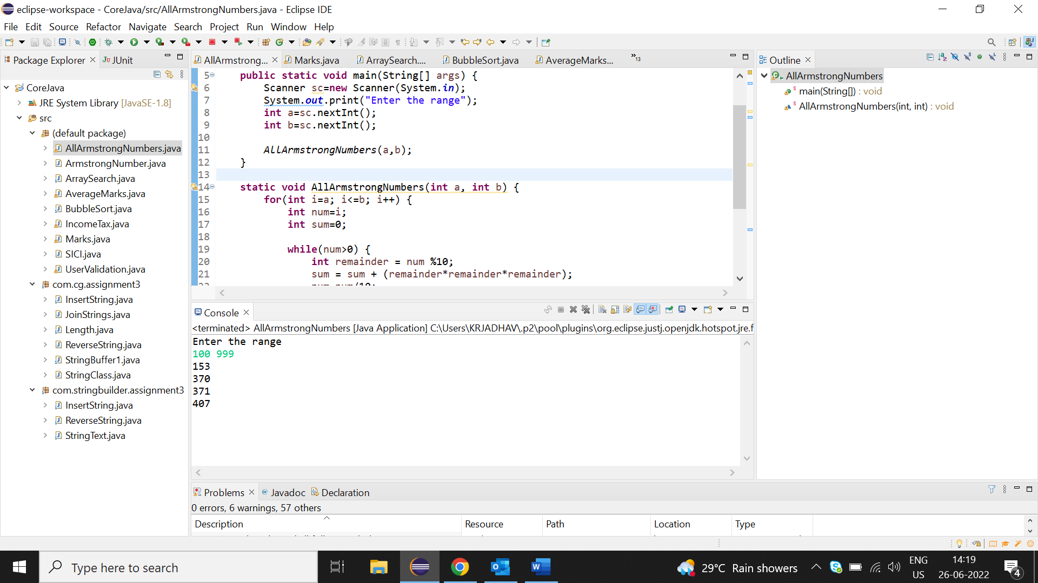

**3.Simple and Compound Interest**

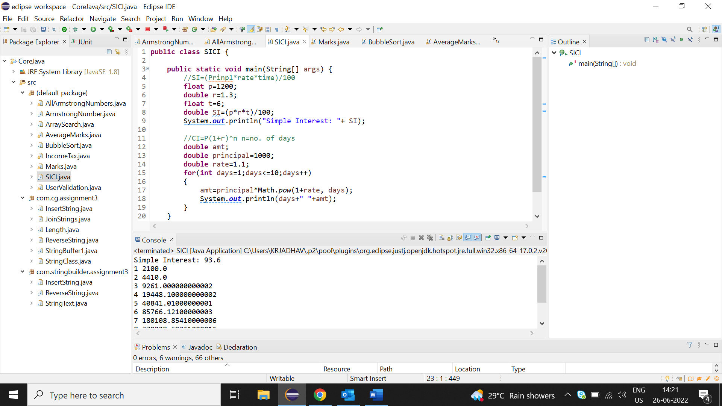

**4. Conditional statements (Passed, Promoted, Failed)**

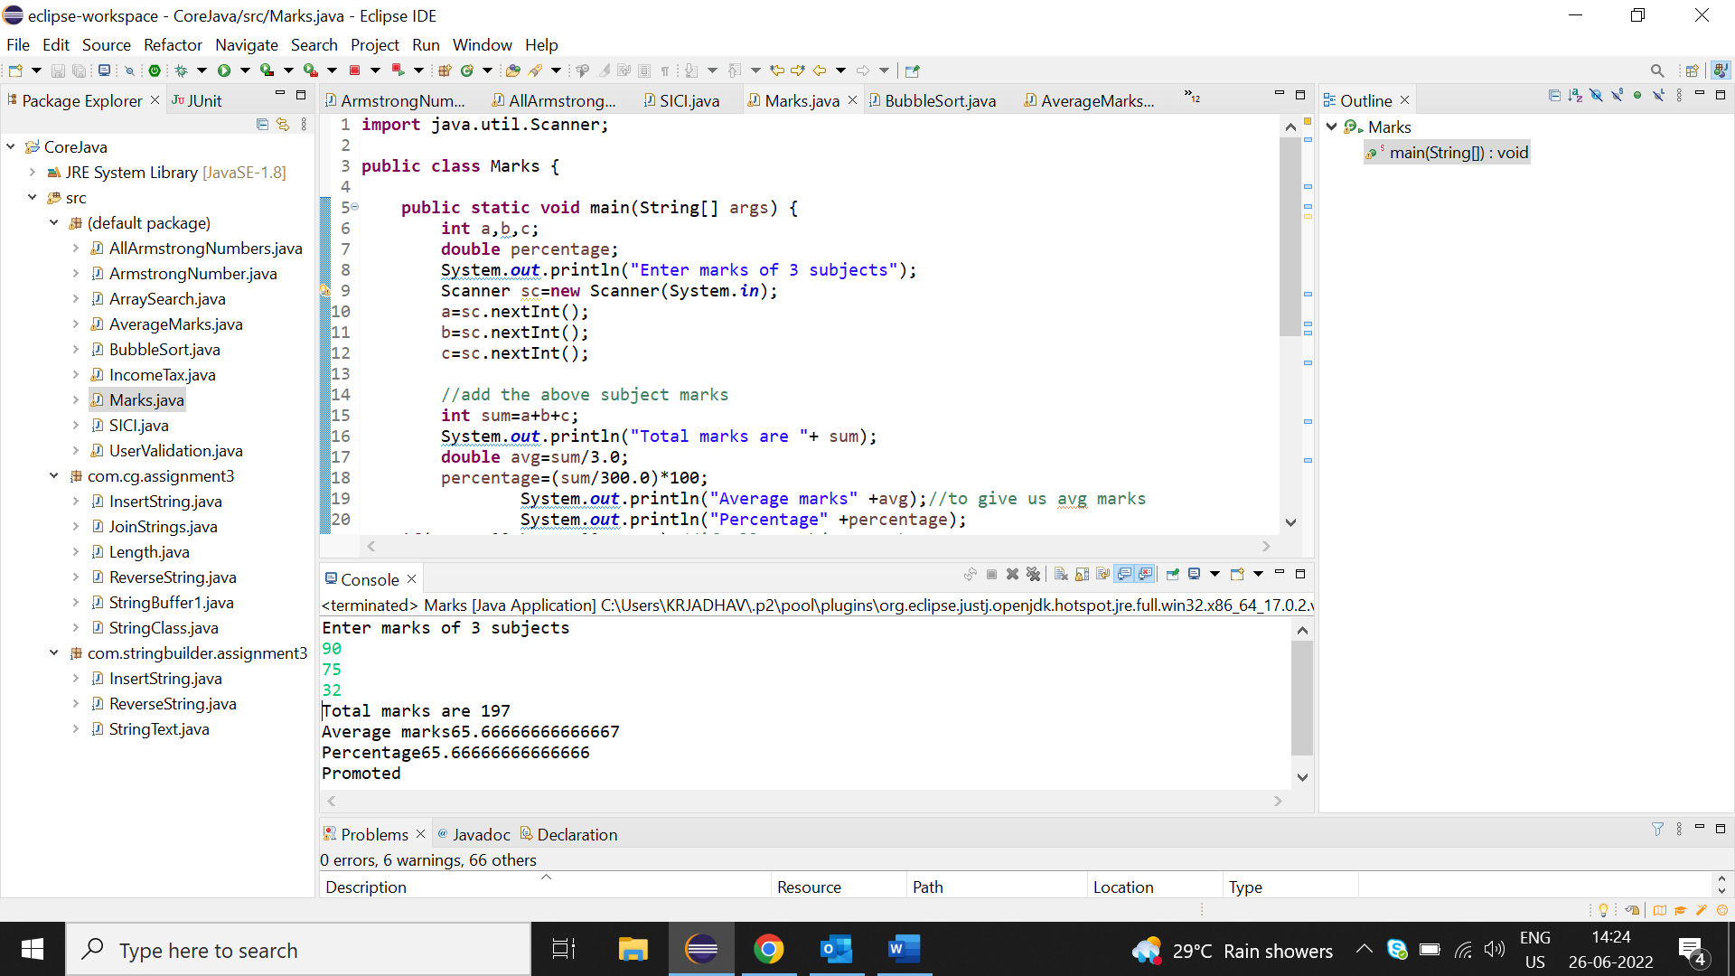

**5.Calculate Income tax with given CTC** 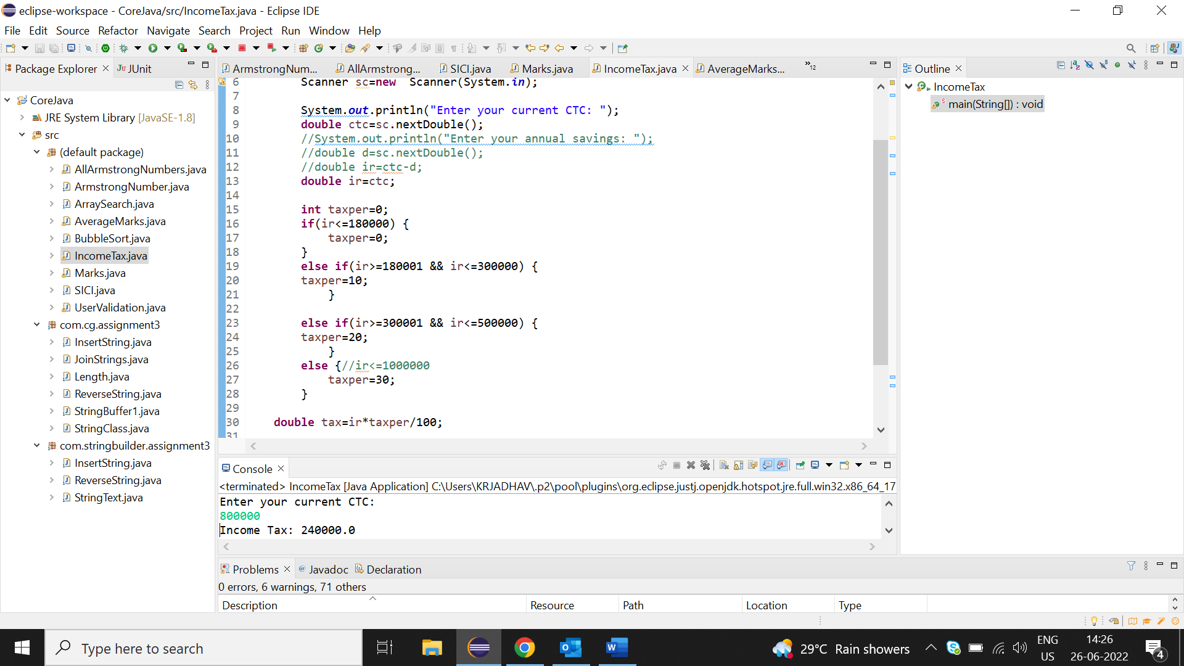

**6.Three Login attempts**

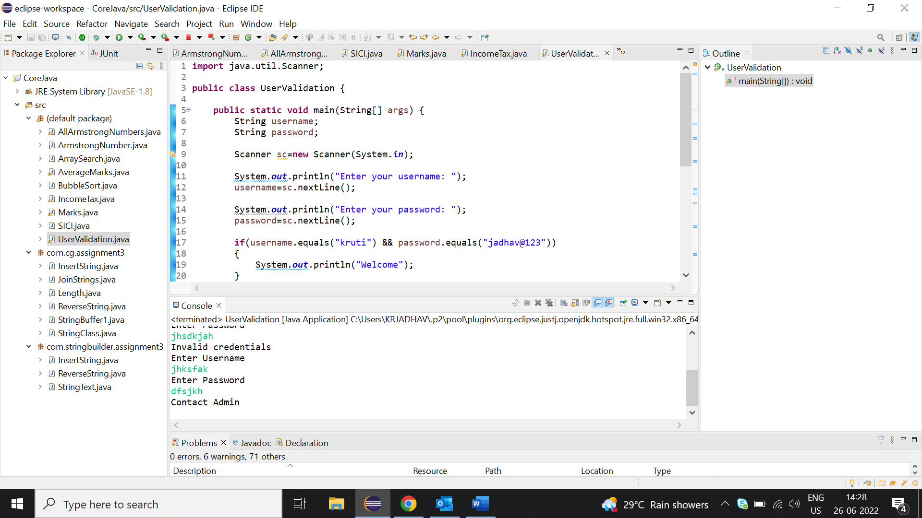

**7.Check no. 19 occurrence in array**

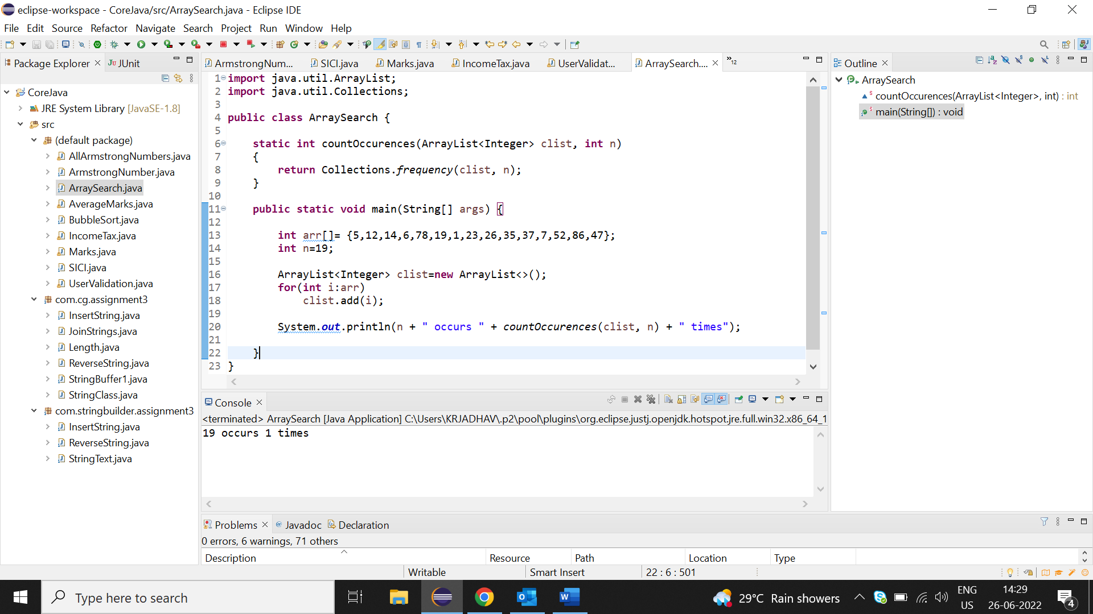

**8.Sorting of given array**

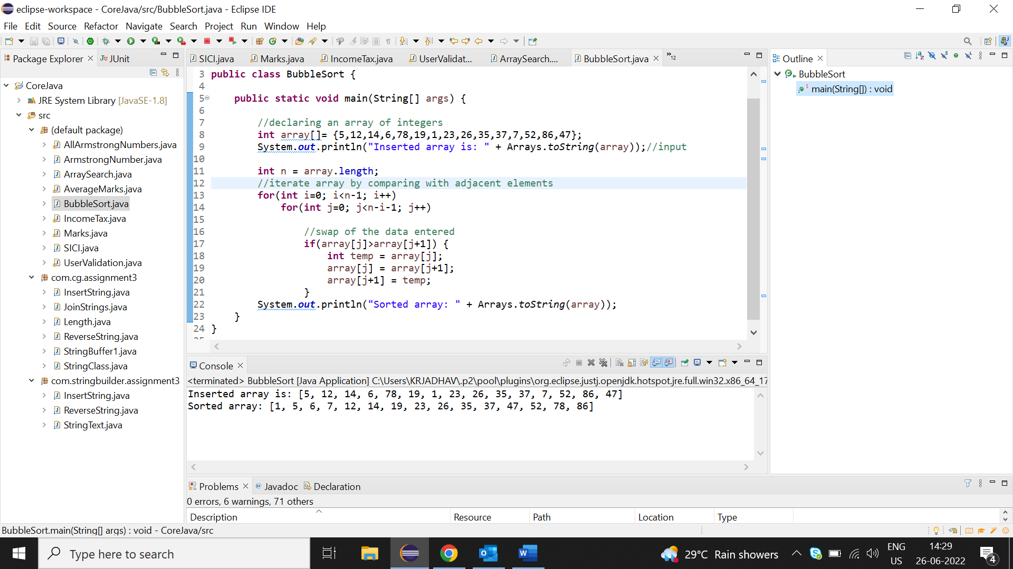

**9.Calculate Total and Avg Marks 3 subjects**

